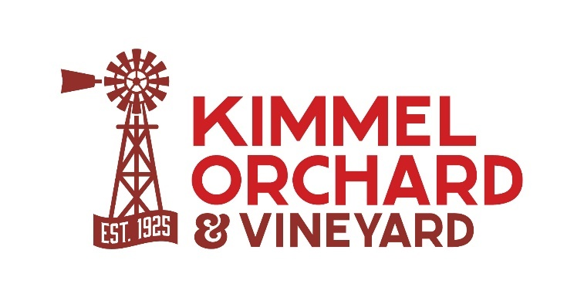
5995 G Road, Nebraska City, NE 68410
(402) 873-5293
info@kimmelorchard.org
www.kimmelorchard.org
2025 Kimmel Antique Tractor Show
Saturday, June 21, 2025

Exhibitor Registration
Name:
Address:
Email:
Cell Phone:
Item to be Exhibited:

Featured Display: Orchard Tractor or Orchard Equipment
Item to be Exhibited:
Please include a photo, if you have one available, for use in promoting the event.
Make:
Model:
Year:
Unique information:

Please submit a completed Exhibitor Registration form by Friday, June 6, 2025.
Email to info@kimmelorchard.org or mail to
Kimmel Orchard & Vineyard, 5995 G Rd, Nebraska City, NE 68410.

